CHEMICAL ENGINEERING TRANSACTIONS  VOL. , 2023 | A publication of
The Italian Association
of Chemical Engineering
Online at www.cetjournal.it

Guest Editors: David Bogle, Flavio Manenti, Piero Salatino
Copyright © 2023, AIDIC Servizi S.r.l.
ISBN 979-12-81206-04-5; ISSN 2283-9216

A critical review on self-heating and self-ignition of biocarbon
Liang Wang*, Øyvind Skreiberg
ª SINTEF Energy Research, Sem Sælands vei 11, NO-7034 Trondheim, Norway

corresponding.author liang.wang@sintef.no
Biocarbon is a promising alternative to replace fossil carbon as reductant for metal production with benefits to reduce greenhouse gas emissions and increase the sustainability of the metallurgical industry. As a carbon and energy intensive industry, a significant amount of biocarbon needs to be produced, handled, transported and stored for further utilization in metal production processes. Biocarbon is a reactive porous material and can undergo self-heating that is related to spontaneous exothermic reactions at low temperatures. The biocarbons can be produced from different biomass materials and under different conditions, and have various physical and chemical properties. The biocarbons with different properties have different tendency in terms of self-ignition and risk of fire. In addition, storage and transportation conditions play also important roles in causing the self-ignition of biocarbon, including gas atmosphere, temperature, heat and mass transfer to surroundings, humidity, etc. Several studies have been conducted to investigate reasons for causing biocarbon self-ignition, including conversion behaviour and mechanisms of biocarbon self-ignition and potential mitigation measures. The main objective of this review is to survey studies on the self-ignition of biocarbons by correlating them to biocarbon production and storage conditions and provide background information for safe transportation and storage of biocarbon.
  - Introduction
Metal production is an energy and material-intensive process consuming large amounts of carbon as reductants and also sources of energy in some metal production processes (Surup, Trubetskaya, and Tangstad 2020). Currently, mainly fossil-based carbonaceous materials such as coal and coke are being used in metal production processes. Metallurgical industries in Norway and the world are actively working on increasing the sustainability of production processes and reducing greenhouse gas (GHG) emissions(Wang et al. 2018). Different measures and solutions have been identified, investigated and developed to make the metal production process more sustainable with less environmental impact. One of these solutions is to produce and use biocarbon, often called charcoal, as an alternative to replacing fossil carbon. Biocarbon is produced from pyrolysis or carbonization of renewable biomass materials that are largely available at low cost(Wang et al. 2016). The CO₂ emitted from the conversion of biocarbon during the metal production process will be further sequestered through photosynthesis as the plant regrow. Through such a biogenic carbon cycle, the utilization of biocarbon for metal production can help to reduce CO₂ emissions from the metallurgical industry(Riva et al. 2020). With further gaining of knowledge, development of technology and large-scale tests, biocarbon use in metal production processes can become economically attractive and technically feasible.
In comparison to conventional fossil carbon, the biocarbon has lower density and the biomass has lower carbon content than coals. It means large amounts of biocarbon need to be produced, transported and stored for further utilization(Wang et al. 2017). In addition, the biocarbon has high porosity and surface area, which makes the biocarbon highly permeable to air and moisture in the ambient atmosphere. It makes the biocarbon a reactive porous media where heterogeneous reactions can take place on the outer surface and within the carbon matrix (Restuccia et al. 2019). The reactions, either endothermic or exothermic, can initiate and proceed under different conditions, which are also related to the physio-chemical properties of biocarbon(Phounglamcheik et al. 2022). Even at low temperatures, some exothermic reactions might take place, which continue and cause a rise of the temperature of biocarbon. The temperature increase of biocarbon is determined by the difference of heat generated and lost(Riva et al. 2020). As the heat generation is more intensive than the heat loss, the exothermic reactions and increase of temperature can lead to smouldering, self-ignition and flaming firing of the biocarbon. There is gradual consumption of carbon along with slow self-heating and smouldering of biocarbon, which also results in the release of volatiles and gases that can be harmful to human health(Nordon, Young, and Bainbridge 1979). Self-ignition is a main challenge for transporting and storing of large amounts of biocarbon, which can lead to serious fire hazards and injuries of operational personnel. Some studies have been conducted to investigate self-heating, self-ignition and storage of biocarbon under different conditions(Nordon, Young, and Bainbridge 1979; Restuccia et al. 2019; Phounglamcheik et al. 2022; Riva et al. 2020; van Blijderveen et al. 2010). This work critically reviews the published studies reporting self-ignition of biocarbon, including 1) general background about self-ignition of biocarbon, 2) summarizing results obtained by using various setups in accordance with specific methodologies and principles, 3) identifying the most influential factors causing self-ignition of biocarbon. Based on the review, recommendations are presented to prevent self-heating and self-ignition for safe storage and transportation of biocarbon.
  - Self-heating and self-ignition of biocarbon
Self-heating of one material can be defined as the phenomenon of a temperature rise in ambient conditions(Carras and Young 1994). The self-heating often is related to chemical and/or physical processes taking place within or on the surface of the material(Restuccia et al. 2019). As the self-heating proceeds, it may lead to a further increase of the temperature of the material, which can exceed a critical temperature. As a result of this, spontaneous self-ignition might occur, leading to the combustion and/or explosion of the material. The temperature rise is critically related to the balance of heat generation and loss of the material(Nordon, Young, and Bainbridge 1979). The heat generated can be from different sources as reported in previous studies. The major heat generation mechanism responsible for the self-heating of biocarbon is the interaction of oxygen with the biocarbon. During storage, the oxygen in the ambient atmosphere can physically and chemically adsorb on the biocarbon surface. The chemical adsorption might lead to the formation of carbon-oxygen complexes and oxygenated carbon species such as carbonyl and other species (Carras and Young 1994). These oxidizing reactions can take place at low temperatures and are oxidimetric. As the heat generated by these reactions is not sufficiently dissipated either by conduction or convection, the temperature rise of biocarbon mass will take place. The interaction between biocarbon and oxygen can lead to the formation of gas products such as carbon monoxide and carbon dioxide, which can be detected and monitored as signals and are evidences of these reactions(Nordon, Young, and Bainbridge 1979; Wang et al. 2017). The other source of heat is the condensation of water vapor(Carras and Young 1994; Onifade and Genc 2020). The amount of water that is condensed and contained at a given value of relative humidity is related to its adsorption and desorption isotherm(Miura 2016). The interaction between the biocarbon and water vapor can be exothermic or endothermic depending on if the water condenses or evaporates. This often occurs as the biocarbon is stored in moist air, the biocarbon grains and fines will adsorb water that condenses with the release of heat. This process might provide the initial energy for spot heating(Miura 2016). It has been observed that the generation of heat related to water adsorption is more evident for dry porous material such as coal. This is because the resistance of water adsorbing on the surface of dry porous materials is much smaller, as the saturation of water can take a certain time onto the external surface and internal porous structure. The third source of heat can be related to the biological degradation of carbon materials as a result of the growth of fungi(Wang et al. 2018). This is especially prone to take place as the biocarbon is stored in an atmosphere with high humidity and high ambient temperature, as such conditions are favorable for growth of fungi. The self-heating and self-ignition are dependent on intrinsic and extrinsic factors. The intrinsic factors are related to physio-chemical properties of biocarbon, including moisture content, volatile matter content, porosity and surface area, density and heat conductivity, etc (Carras and Young 1994; Onifade and Genc 2020; Restuccia et al. 2019). The extrinsic factors are those external conditions including atmosphere, humidity, temperature, ventilation, air pressure and sun radiation, etc (Phounglamcheik et al. 2022).
  - Studies on self-heating and self-ignition of biocarbon
Self-heating and self-ignition of biocarbon are generally linked to heat production, temperature rise, mass variation, oxygen adsorption and consumption, and gas emissions. Therefore experimental studies and tests have been carried out in order to identify, measure and assess these indicators, reveal underlining mechanisms and propose possible abating solutions.
    - Thermal gravimetric analysis
Thermal gravimetric analysis (TGA) combined with differential scanning calorimetry (DSC) has been used as a straightforward way to examine mass change and heat released during the slow oxidization of biocarbon under controlled conditions(Phounglamcheik et al. 2022; Restuccia et al. 2019; Riva et al. 2020). For a normal TGA/DSC experiment, one biochar sample in mg weight is loaded in the TGA/DSC. With the high accuracy balance, even the change of sample weight due to chemisorption can be detected and monitored(Phounglamcheik et al. 2022). In addition, a sudden drop of sample weight can be observed from the TG curve at a certain temperature, which is related to the self-ignition of biocarbon accompanied by intensive consumption of the sample. Figure 1 shows TG curves (three repetitions at each test condition) of biocarbon powders upon heating at 50 ºC with the presence of 20% O2 and 150 ºC with the presence of 10% O₂ for 180 minutes(Phounglamcheik et al. 2022). For one experiment, one sample was first heated at 340 °C with a holding time of 30 min under pure N₂ (purity = 99.996%) to desorb O₂ gas molecules on the char sample. Afterwards the sample is cooled down to a desired isothermal temperature (i.e., 50 ºC) and then purged with a gas mixture with a certain O₂ concentration (i.e., 5 vol%) in N₂(Phounglamcheik et al. 2022). It was stated that the increase of sample mass is mainly related to the adsorption of O2 onto the sample(Phounglamcheik et al. 2022). The evident decrease in sample weight can be related to the saturation of oxygen and possible interactions of the adsorbed oxygen with biocarbon.
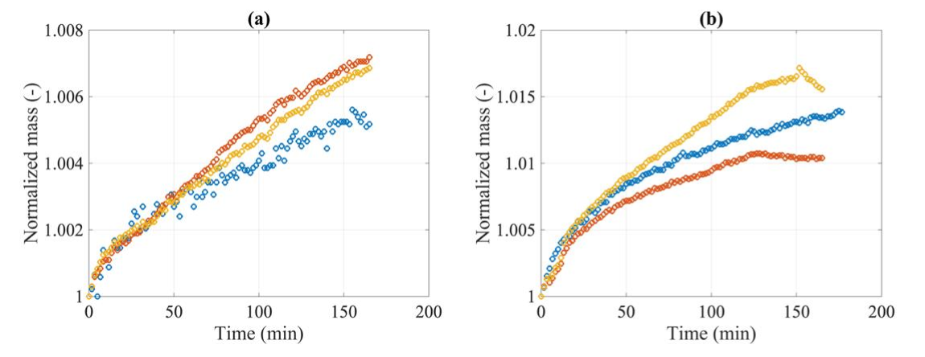
Figure 1. TG curves of biocarbon powders (d <75 µm) upon heating at a) 50 ºC and 20% O2 b) 150 ºC and 10% O2 for 180 minutes (Phounglamcheik et al. 2022).
    - Fixed bed experiment
Fixed bed experiment is normally used to heat the biocarbon sample at an isothermal condition, where the temperature and test time are fixed(Riva et al. 2020; van Blijderveen et al. 2010). The temperature in the sample bed is measured continuously, which is compared to the ambient temperature. Figure 2 displays the temperature history of three biocarbon samples over time(Riva et al. 2020). The biocarbon was first loaded in a container and then placed in a furnace with a pre-set temperature of 140°C and measurement of the temperature in the container. Upon heating at 140°C in the oven, self-heating might happen, which causes a temperature rise of the biocarbon mass(Riva et al. 2020). If the temperature of the biocarbon sample (T_{s}, displayed as black, blue and orange solid lines in Figure 2) bed is higher than the ambient temperature (T_{a}, displayed as black dash lines in Figure 2), a difference between T_{s} and T_{a} can be observed. Consequently, there will be a continuous loss of heat from the biocarbon sample to air streams and the temperature of the biocarbon mass will eventually approach the ambient temperature or airflow temperature. It will result in a temperature decrease of biocarbon mass with a reducing difference of T_{s} and T_{a}(Riva et al. 2020). However, as the heat, which is generated from the reactions and processes mentioned in section 2 above, is larger than the heat lost to air streams, the biocarbon mass will continue to heat up.

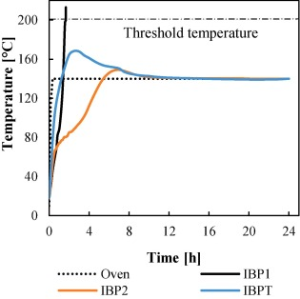
Figure 2. Temperature history of biocarbon samples during self-heating test
As shown in Figure 2, the temperature measured from the sample IBP1 increases sharply, continuously to a value over 200°C, indicating temperature runaway and self-ignition of the sample under the tested condition(Riva et al. 2020). The IBP samples are both biocarbon pellets, whereas the IBPT sample was derived from IBP1 after being heat treated at 600°C. The IBP2 sample is carbonized wood chips. In comparison to the biocarbon chips, the biocarbon pellet has a higher density and low thermal conductivity. It means that the heat generated in the biocarbon pellet bed in the container can not sufficiently dissipate either by conduction or convection, hence an increase in temperature within the biocarbon mass arises(Riva et al. 2020). On the other hand, the temperature increase rate of the biocarbon chips is much lower. Only a very small difference between the sample mass temperature and ambient temperature was detected. It can be related to the porous structure of the biocarbon chips with much more free spaces (i.e., voids), which allows more rapid heat transfer and limits the accumulation of heat.
    - Basket experiment
Basket experiment is one method to investigate the bulk behavior of biomass self-heating and ignition and determine the critical ambient temperature for self-ignition. For one basket experiment, a biocarbon sample is loaded in a basket and heated at one given temperature. If the sample failed to reach ignition, the experiment is repeated with a fresh sample at a higher temperature. If self-ignition occurs for the sample, then the experiment is repeated with a fresh sample at a lower temperature (Carras and Young 1994). In such a way, a minimum ambient temperature can be obtained, at which the self-ignition of one biocarbon sample might happen as it retains at this temperature with sufficient time. Figure 3 shows minimum self-ignition temperatures detected from the basket test using softwood pellets and biocarbon produced from the pellet at a temperature between 350 °C and 800 °C (Restuccia et al. 2019). It can be seen that, for softwood biochar produced at 450 °C, only a temperature of 90 °C is needed to initiate self-ignition. It is possible to upscale the test results by further predictions based on the thermal and kinetic parameters obtained in the self-heating experiments and the Frank-Kamenetskii theory (Miura 2016; Restuccia et al. 2019). The upscaling results showed that self-ignition of the softwood biocarbon pellets produced at 450 °C can take place at as low as 20 °C if the amount of stored biocarbon is large enough. For most of the industrial applications, the biocarbon will be transported via truck or piled for storage in a large volume. The biocarbon has direct contact with air as an oxidizer. In addition, there will be an accumulation of heat and gaseous products from oxidization of the biocarbon mass (i.e., the center of the pile). The self-ignition can take place in these regions spontaneously and intensively, which act as fire spots to ignite the whole biocarbon pile consequently.

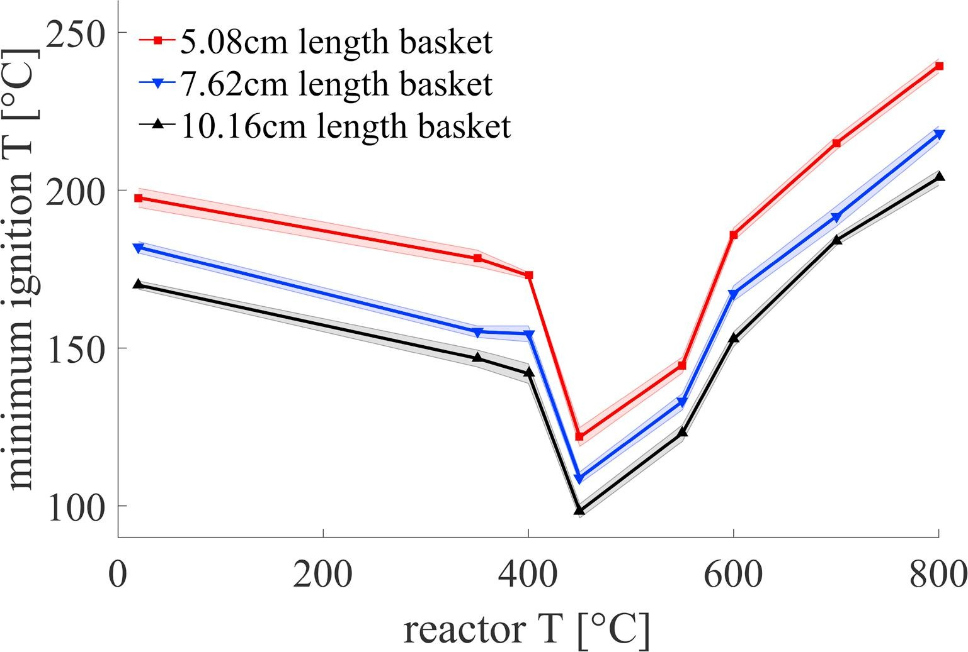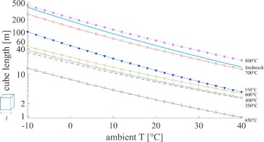
Figure 3: (a) Detected minimum ignition temperature for softwood and biocarbon produced between 350 °C and 800 °C using baskets with three sizes
  - Storage of biocarbon
Large amounts of biocarbon need to be produced, transported and stored for final metallurgical applications. The storage of biocarbon can be days, weeks and even months, which can be in containers and as piles with different sizes and shapes either indoors or outdoors. Safe storage of biocarbon is an important issue to be addressed. Several investigators have conducted experimental and modeling work to investigate and predict the self-heating and thermal runaway of biochar in containers that are made of different materials with different sizes(Nordon, Young, and Bainbridge 1979; Phounglamcheik et al. 2022; Restuccia et al. 2019). Figure 4 (a) shows temperatures measured from different spots in a closed container with biocarbon stored inside. The figure clearly shows an increase of temperature inside the container after a storage time of 15 hours(Phounglamcheik et al. 2022). In addition, there are also differences in terms of temperature along both vertical and horizontal directions. The temperatures close to the center of the container are higher than those measured in the spots close to the wall, top and bottom of the container(Phounglamcheik et al. 2022). In the same work, the temperature that can secure safe storage of biocarbon in containers made of different materials was also identified. It was found that the maximum safe storage temperature of studied biocarbon in the closed metal container is higher than that for using the woven bag(Phounglamcheik et al. 2022). One explanation for this is the amount of oxygen available for initiating self-ignition of biocarbon in different containers. In the closed metal container, the oxygen is consumed in the stage of chemisorption(Phounglamcheik et al. 2022). The temperature of biocarbon will decrease with a lack of sufficient air for further oxidizing reactions that release heat causing self-ignition. On the other hand, the biocarbon has access to air that flows into the woven bag during the storage process. It will provide oxidizer for continuing chemisorption and surface reactions with releasing of heat as well(Phounglamcheik et al. 2022).
During transportation or storage, biocarbon can experience various conditions, for example high humidity and temperature. The properties of biocarbon might change under these conditions, which will affect their properties as used for metal production processes(Wang et al. 2018). With considering this, long time tests were conducted by storing biocarbon under humid (98% relative humidity) and relatively high temperature (35 °C) in a climate chamber(Wang et al. 2018). The biocarbon after a certain storage time was taken out to characterize properties relevant to metal production. It was found that the fixed carbon content of the biocarbon reduced upon longer storage time (Figure 5(a)). In addition, the growth of fungi was also observed from the biocarbon during the storage tests (Figure 5(b)). It indicates possible loss of biocarbon due to biological degradation as a result of the growth of fungi(Wang et al. 2018).

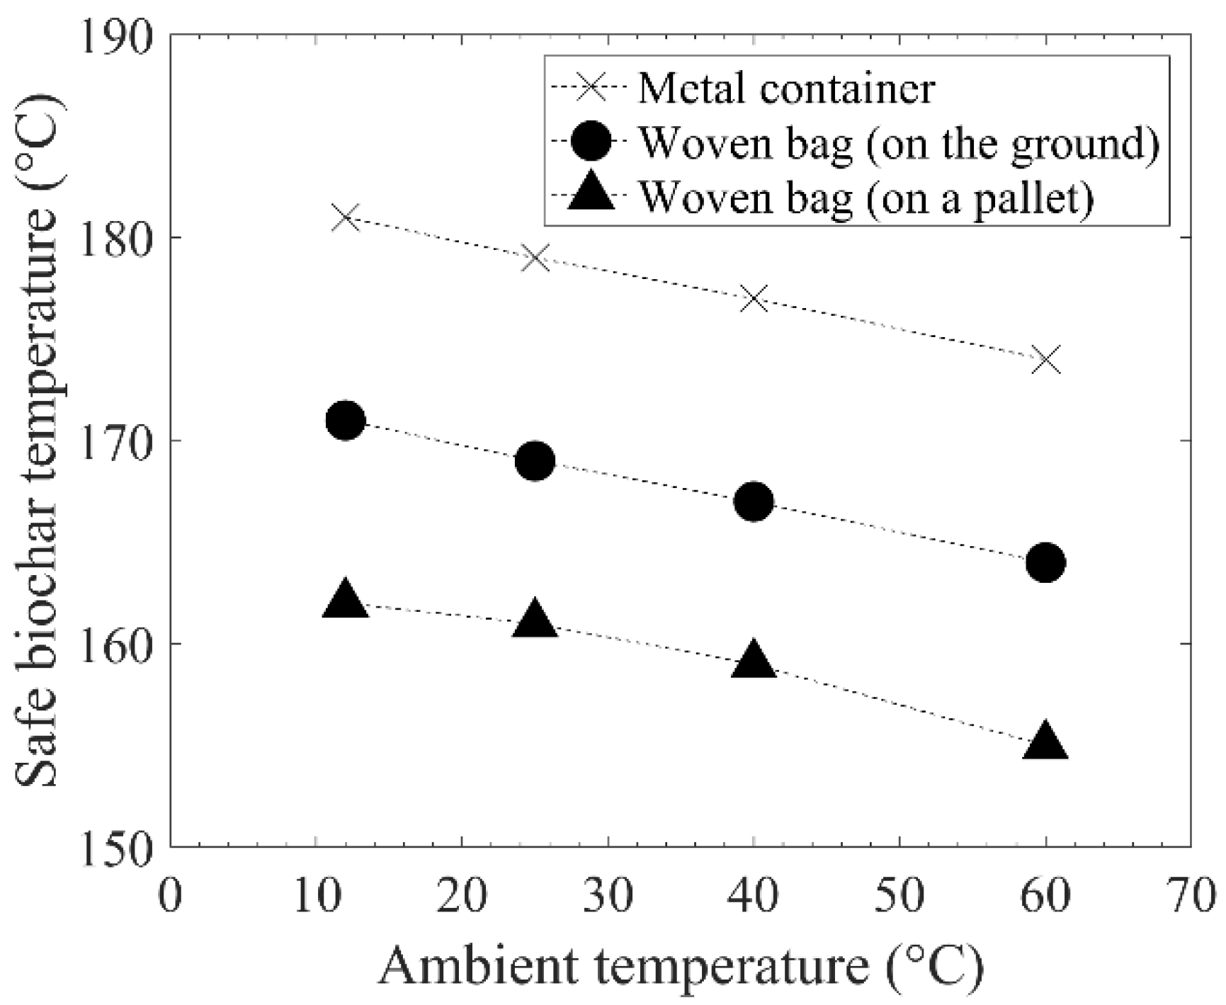
(b)
Figure 4: Tests of storage of biocarbon in different containers, (a) measured temperature as a function of time at different locations in the metal container, (b) safe biochar storage temperatures with different types of container
(a)
(b)
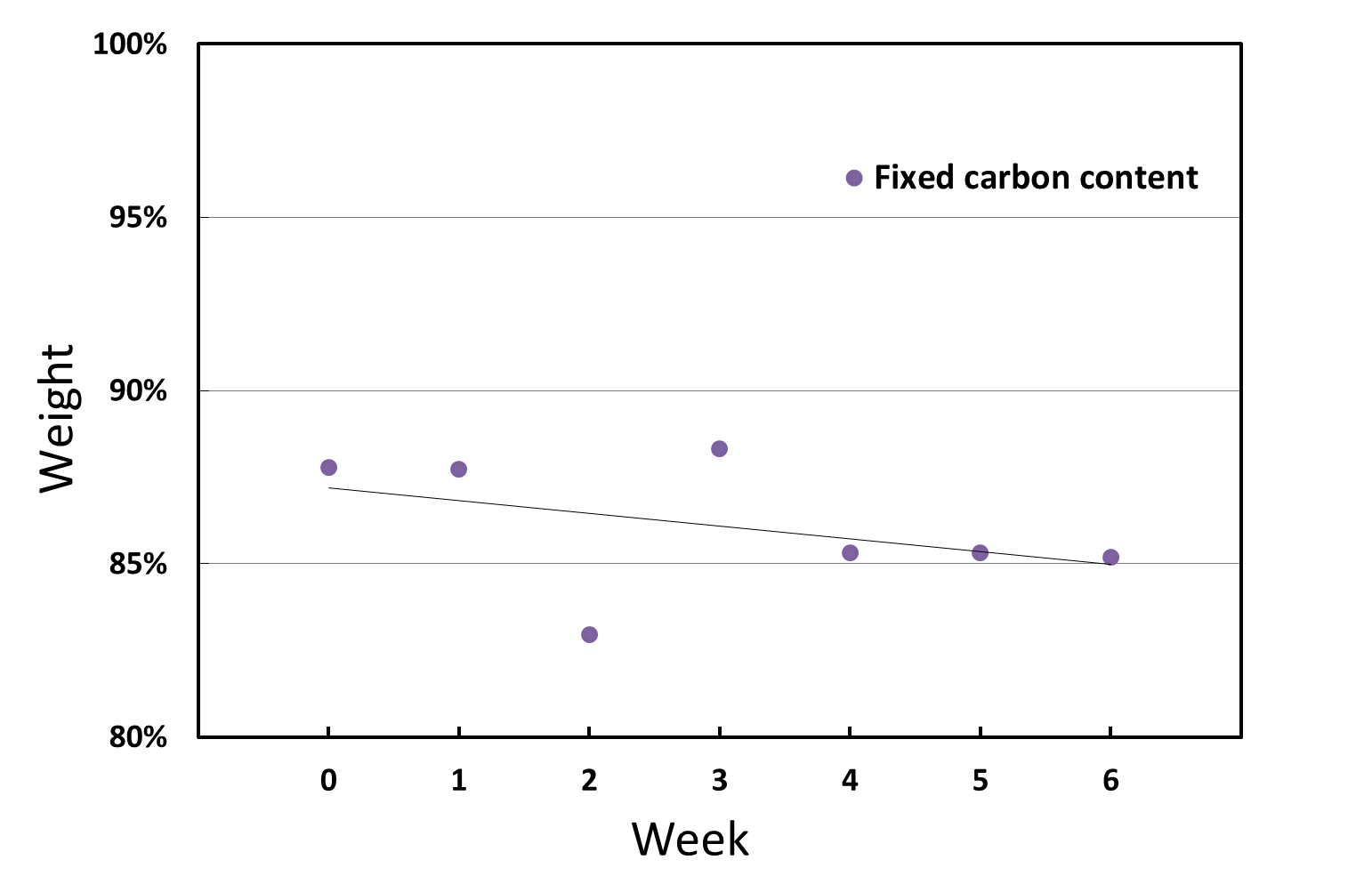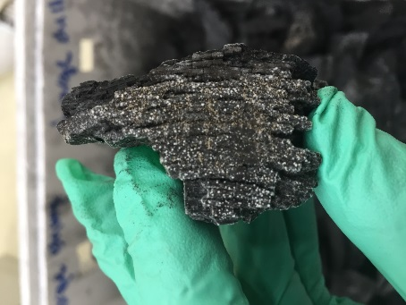
Figure 5: (a) change of fixed carbon content of biocarbon during storage test, (b) growth of fungi on biocarbon
  - Conclusions
In this work, theoretical background and experimental studies on self-heating and self-ignition of biocarbon were critically reviewed. The self-heating and self-ignition of biocarbon are associated with complex physical and chemical processes and reactions, which can be affected by many factors. Among these factors, ambient temperature, availability of oxygen and storage time have been studied and reported. It was found that access of biocarbon to oxygen is critical for starting and continuation of chemisorption and surface reactions, which are often the main sources of heat to cause self-heating and self-ignition of biocarbon. There is more work needed to study the effect of surrounding conditions such as humidity on self-ignition of biocarbon, as water vapor can play important role in generating heat and catalyzing surface reactions. In addition, more detailed characterizations of biocarbon sampled from the storage tests should be conducted. It enables to link self-ignition tendency of the biocarbon with the properties of biocarbon, which can be altered by manipulating production conditions and applying upgrading measures.
Acknowledgments
The authors acknowledge the financial support from the Research Council of Norway and the BioCarbUp and BioCarbUpgrade project industry partners: Elkem AS - Department Elkem Technology, Eramet Norway AS, Norsk Biobrensel AS, Eyde Cluster, Hydro Aluminium AS, WAI Environmental Solutions, OBIO AS, and Alcoa Norway ANS.
References

Blijderveen, Maarten van, Eyerusalem M. Gucho, Eddy A. Bramer, and Gerrit Brem. 2010. “Spontaneous Ignition of Wood, Char and RDF in a Lab Scale Packed Bed.” Fuel 89 (9): 2393–2404. https://doi.org/10.1016/j.fuel.2010.01.021.
Carras, John N., and Brian C. Young. 1994. “Self-Heating of Coal and Related Materials: Models, Application and Test Methods.” Progress in Energy and Combustion Science 20 (1): 1–15. https://doi.org/10.1016/0360-1285(94)90004-3.
Miura, Kouichi. 2016. “Adsorption of Water Vapor from Ambient Atmosphere onto Coal Fines Leading to Spontaneous Heating of Coal Stockpile.” Energy & Fuels 30 (1): 219–29. https://doi.org/10.1021/acs.energyfuels.5b02324.
Nordon, Peter, Brian C. Young, and Norman W. Bainbridge. 1979. “The Rate of Oxidation of Char and Coal in Relation to Their Tendency to Self-Heat.” Fuel 58 (6): 443–49. https://doi.org/10.1016/0016-2361(79)90086-3.
Onifade, M., and B. Genc. 2020. “A Review of Research on Spontaneous Combustion of Coal.” International Journal of Mining Science and Technology 30 (3): 303–11. https://doi.org/10.1016/j.ijmst.2020.03.001.
Phounglamcheik, Aekjuthon, Nils Johnson, Norbert Kienzl, Christoph Strasser, and Kentaro Umeki. 2022. “Self-Heating of Biochar during Postproduction Storage by O2 Chemisorption at Low Temperatures.” Energies 15 (1): 380. https://doi.org/10.3390/en15010380.
Restuccia, Francesco, Ondřej Mašek, Rory M. Hadden, and Guillermo Rein. 2019. “Quantifying Self-Heating Ignition of Biochar as a Function of Feedstock and the Pyrolysis Reactor Temperature.” Fuel 236 (January): 201–13. https://doi.org/10.1016/j.fuel.2018.08.141.
Riva, Lorenzo, Alessandro Cardarelli, Geir Johan Andersen, Therese Videm Buø, Marco Barbanera, Pietro Bartocci, Francesco Fantozzi, and Henrik Kofoed Nielsen. 2020. “On the Self-Heating Behavior of Upgraded Biochar Pellets Blended with Pyrolysis Oil: Effects of Process Parameters.” Fuel 278 (October): 118395. https://doi.org/10.1016/j.fuel.2020.118395.
Surup, G.R., A. Trubetskaya, and M. Tangstad. 2020. “Charcoal as an Alternative Reductant in Ferroalloy Production: A Review.” Processes 8 (11): 1–41. https://doi.org/10.3390/pr8111432.
Wang, L., E. Barta-Rajnai, K. Hu, C. Higashi, O. Skreiberg, M. Grønli, Z. Czégény, et al. 2017. “Biomass Charcoal Properties Changes during Storage.” In , 105:830–35. https://doi.org/10.1016/j.egypro.2017.03.397.
Wang, L., F. Buvarp, Ø. Skreiberg, and R. Khalil. 2018. “Impact of Storage Time and Conditions on Properties of Biocarbon.” Chemical Engineering Transactions 65: 715–20. https://doi.org/10.3303/CET1865120.
Wang, L., B. Hovd, H.-H. Bui, A. Valderhaug, T.V. Buø, R.G. Birkeland, Ø. Skreiberg, and K.-Q. Tran. 2016. “CO2 Reactivity Assessment of Woody Biomass Biocarbons for Metallurgical Purposes.” Chemical Engineering Transactions 50: 55–60. https://doi.org/10.3303/CET1650010.

